# **ASSIGNMENT - 3**

1. **Write a program to search an element present in the array**

**Code:**

import java.util.Scanner;

class Search {

public static void main(String args[]) {

Scanner sc = new Scanner(System.in);

System.out.println("Enter the size of array:");

int n = sc.nextInt();

int arr[] = new int[n];

System.out.println("Enter the elements of array:");

for (int i = 0; i < n; i++)

{

arr[i] = sc.nextInt();

}

System.out.println("Enter the element to search:");

int ele = sc.nextInt();

boolean found = false;

for (int i = 0; i < n; i++)

{

if (arr[i] == ele)

{

System.out.println("Element found at index " + i);

found = true;

break;

}

}

if (!found) {

System.out.println("Element not found in the array.");

}

}

}**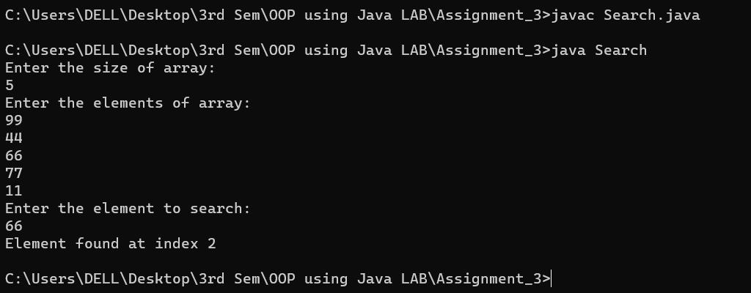Output:**

1. **Write a program to sort the array of n elements.**

**Code:**

import java.util.Arrays;

import java.util.Scanner;

class Sort{

public static void main(String args[]) {

Scanner sc = new Scanner(System.in);

System.out.println("Enter the size of array:");

int n = sc.nextInt();

int arr[] = new int[n];

System.out.println("Enter " + n + " elements:");

for (int i = 0; i < n; i++) {

arr[i] = sc.nextInt();

}

Arrays.sort(arr);

System.out.println("Sorted Array:");

for (int i = 0; i < n; i++) {

System.out.print(arr[i] + " ");

}

}

}

**Output:**

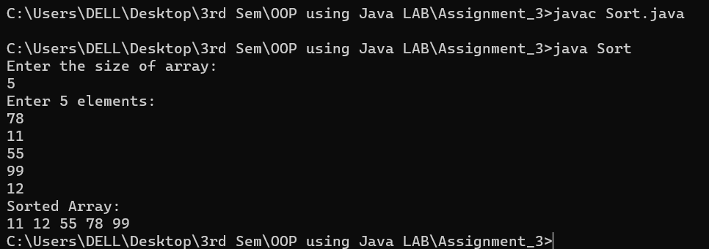

1. **Write a program input two matrices and perform the addition of two matrices.**

**Code:**

import java.util.Scanner;

class MatAdd{

public static void main(String args[]) {

Scanner sc = new Scanner(System.in);

System.out.println("Enter number of rows:");

int rows = sc.nextInt();

System.out.println("Enter number of columns:");

int cols = sc.nextInt();

int a[][] = new int[rows][cols];

int b[][] = new int[rows][cols];

int sum[][] = new int[rows][cols];

System.out.println("Enter elements of first matrix:");

for (int i = 0; i < rows; i++) {

for (int j = 0; j < cols; j++) {

a[i][j] = sc.nextInt();

}

}

System.out.println("Enter elements of second matrix:");

for (int i = 0; i < rows; i++) {

for (int j = 0; j < cols; j++) {

b[i][j] = sc.nextInt();

}

}

for (int i = 0; i < rows; i++) {

for (int j = 0; j < cols; j++) {

sum[i][j] = a[i][j] + b[i][j];

}

}

System.out.println("Resultant Matrix (Addition):");

for (int i = 0; i < rows; i++) {

for (int j = 0; j < cols; j++) {

System.out.print(sum[i][j] + " ");

}

System.out.println();

}

}

}

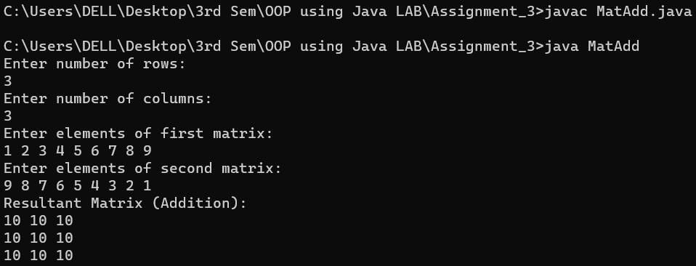**Output:**

1. **Write a program that performs the addition of two numbers using command-line arguments.**

**Code:**

class Sum{

public static void main(String args[]) {

if (args.length < 2)

{

System.out.println("Enter two numbers as : ");

return;

}

int num1 = Integer.parseInt(args[0]);

int num2 = Integer.parseInt(args[1]);

int sum = num1 + num2;

System.out.println("The sum of " + num1 + " and " + num2 + " is: " + sum);

}

}

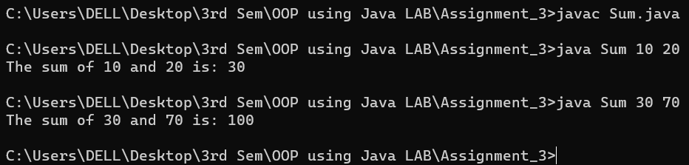**Output:**

**5. Write a program that will take two integer numbers from the command prompt and find their GCD. If the user does not provide exactly two numbers of arguments then the program should display error message.**

**Code:**

public class GCD {

public static int gcd(int a, int b) {

if (b == 0) {

return a;

} else {

return gcd(b, a % b);

}

public static void main(String[] args) {

int num1 = Integer.parseInt(args[0]);

int num2 = Integer.parseInt(args[1]);

int res = gcd(num1, num2);

System.out.println("GCD of " + num1 + " and " + num2 + " is: " + res);

}

**Output:**

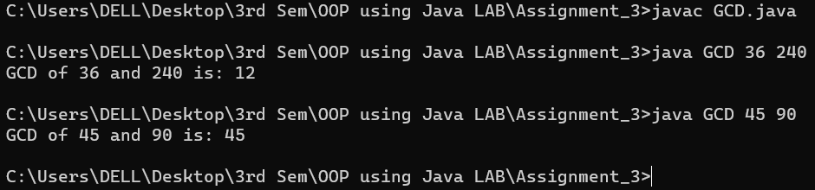

1. **Write a program that will take employee id, employee name, department number, salary from the command prompt. If the user does not provide exactly four numbers of arguments then the program should display error message. Use methods display() to display the record of employee.**

**Code:**

public class Employee {

int empId;

String empName;

int deptNo;

double salary;

public Employee(int empId, String empName, int deptNo, double salary) {

this.empId = empId;

this.empName = empName;

this.deptNo = deptNo;

this.salary = salary;

}

public void display() {

System.out.println("Employee Details:");

System.out.println("ID : " + empId);

System.out.println("Name : " + empName);

System.out.println("Dept No. : " + deptNo);

System.out.println("Salary : " + salary);

}

public static void main(String[] args)

{

if (args.length != 4) {

System.out.println("Error: Please provide exactly 4 arguments.");

return;

}

int id = Integer.parseInt(args[0]);

String name = args[1];

int dept = Integer.parseInt(args[2]);

double sal = Double.parseDouble(args[3]);

Employee emp = new Employee(id, name, dept, sal);

emp.display();

}

}

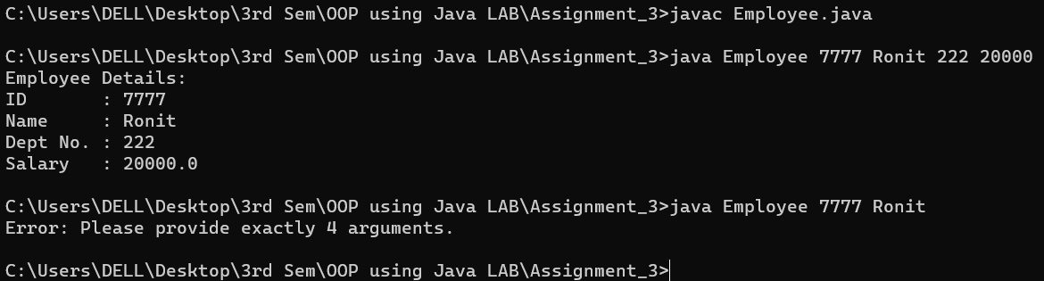**Output:**

1. **Write a program to accept the SIC, name, branch and marks of six subjects using command line argument. Calculate the average marks.**

**Code:**

public class Student {

public static void main(String[] args)

{

String sic = args[0];

String name = args[1];

String branch = args[2];

int total = 0;

for (int i = 3; i < 9; i++)

{

total += Integer.parseInt(args[i]);

}

double average = total / 6.0;

System.out.println("Student Details:");

System.out.println("SIC : " + sic);

System.out.println("Name : " + name);

System.out.println("Branch : " + branch);

System.out.println("Average Marks = " + average);

}

}

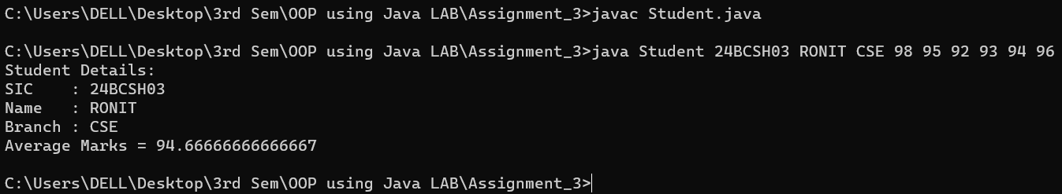**Output:**

1. **Write a program to input a jagged array and display it.**

**Code:**

import java.util.Scanner;

public class JagArr {

public static void main(String[] args) {

Scanner sc = new Scanner(System.in);

System.out.print("Enter number of rows: ");

int rows = sc.nextInt();

int[][] jagged = new int[rows][];

for (int i = 0; i < rows; i++) {

System.out.print("Enter number of columns in row " + (i + 1) + ": ");

int cols = sc.nextInt();

jagged[i] = new int[cols];

System.out.println("Enter " + cols + " elements for row " + (i + 1) + ":");

for (int j = 0; j < cols; j++) {

jagged[i][j] = sc.nextInt();

}

}

System.out.println("\nJagged Array:");

for (int i = 0; i < jagged.length; i++) {

for (int j = 0; j < jagged[i].length; j++) {

System.out.print(jagged[i][j] + " ");

}

System.out.println();

}

}

}

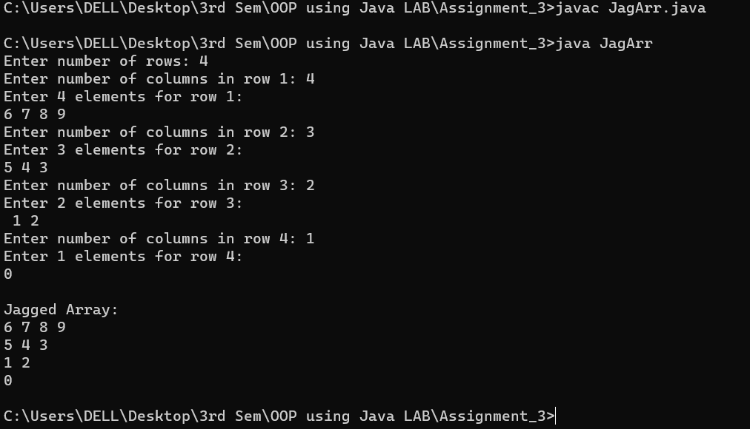**Output:**